

**IS204.3 Business Process Management  
Group Assignment  
Batch: UGC MIS 21.1**



**Group Members…**

S. B. D. Liyanage 22756

L. B. Weerawikrama 24134

P. S. Liyanachchi 23734

I. B. S. Hasal 23078

Content… Page…

Group members 02

Content page 03

Organization description 04

Scope of the process 06

Process discovery methods 07

As-is system 08

Organization description…

Company: D.K. Pawing Center Dehiaththakandiya.

For this project we decided to choose D. K. Pawning Center located in Dehiaththakandiya area. Mr. I. B. Jayantha Raja is the owner of this business, and he started this mortgage center on 27/01/2021 and he has been running this business for over two years continuously. This is a sole proprietorship small scale business, and this business is run by him according to the mortgage laws and regulations that have been maintained by the government.

This business is built on two main processes. They are, giving money to the customer after receiving gold items from the customers, and saving the gold items that are going to lost to a certain organization and giving an appropriate amount to the customer.

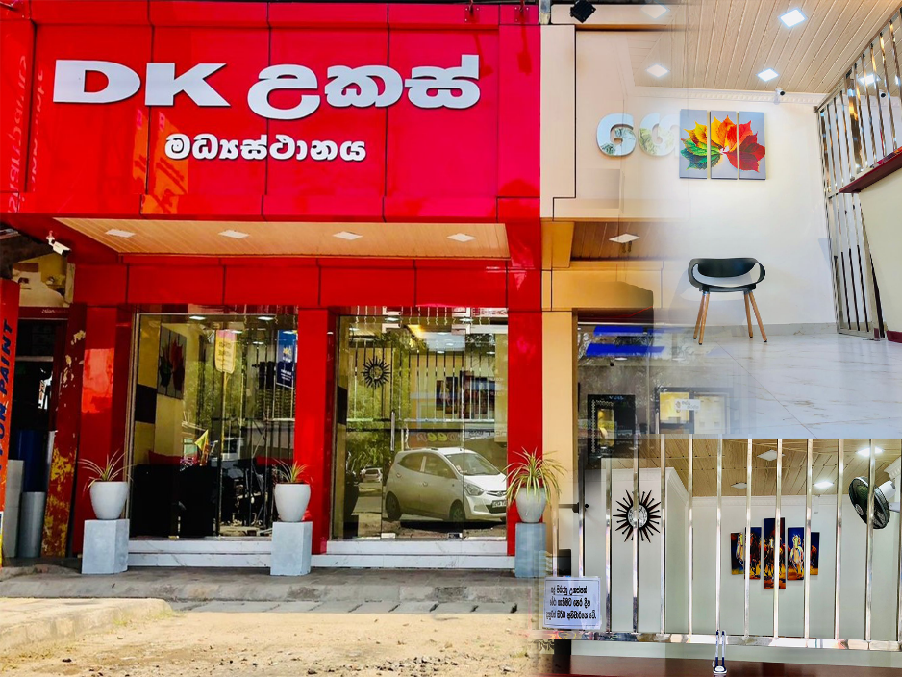As a proper description of the work done in here, mainly D. K. Pawing Center give money by depositing gold (Exchange money with gold) for a certain period with an agreement. In here, for the gold items received from the customers, money is given as a mortgage according to the gold price and interest rate prevailing on that day. Also, if the customer couldn’t save their gold which deposit in another company, D. K. Pawing Center can buy those gold items as a mortgage according to the customer request and give appropriate amount of money to the customer. They usually keep every detail about the business in their own manual data repository and usually work 2-3 members in the shop. With the economic crisis, the customers of the business got bit increase and the work situation got bit busy some days. The shop open from 9.00 am to 8.00 pm in weekdays and in weekends it closes at 6.00 pm.

***Img.1***

Scope of the process…

As mentioned earlier, this business is built on two main processes,

1. Take golden items from the customers and give suitable amount of money to them.
2. Save gold items which deposited in other organizations as the request of customers.

The first process mentioned above is the most popular and frequently do in this business. In this process we can identify three main sub processes. They are, pricing process for the gold items, process of fixing interest rates for gold commodities, foreclosure of overdue mortgages. All these processes are carried out under the supervision of the owner. The process starts when the customer brings their gold items to the shop, and it ends after the customer receive the money with the mortgage bill.

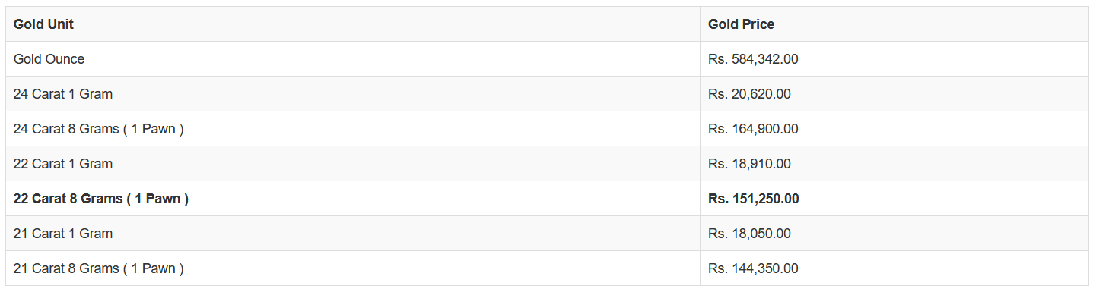The customer first come to the shop and discuss the situation with the mortgagee or the shop owner to know the value of the golden item he/she have and the interest rate that he/she have to pay. To start pricing the gold item, mortgagee send those gold items to the owner of the shop. He checks and categories the type of the gold item weather it is a chain, bracelet, ring, pendent, earing, etc. and scale the weight of each gold item. After the categorizing, start to measure the carat amount of the gold item and check the price table which updated at that moment. (*10 March 2023 price table: ‘img.2’*). After that, the interest percentage is determined in relation to that gold item/s. To fix the interest percentage, first get the total weight of the gold item/s given by the customer. If the total weight is equal or less than Rs. 20,000/=, the interest rate set to 5% and otherwise total weight is greater than Rs. 20,000/= the interest rate set to 4%.

***Img.2***

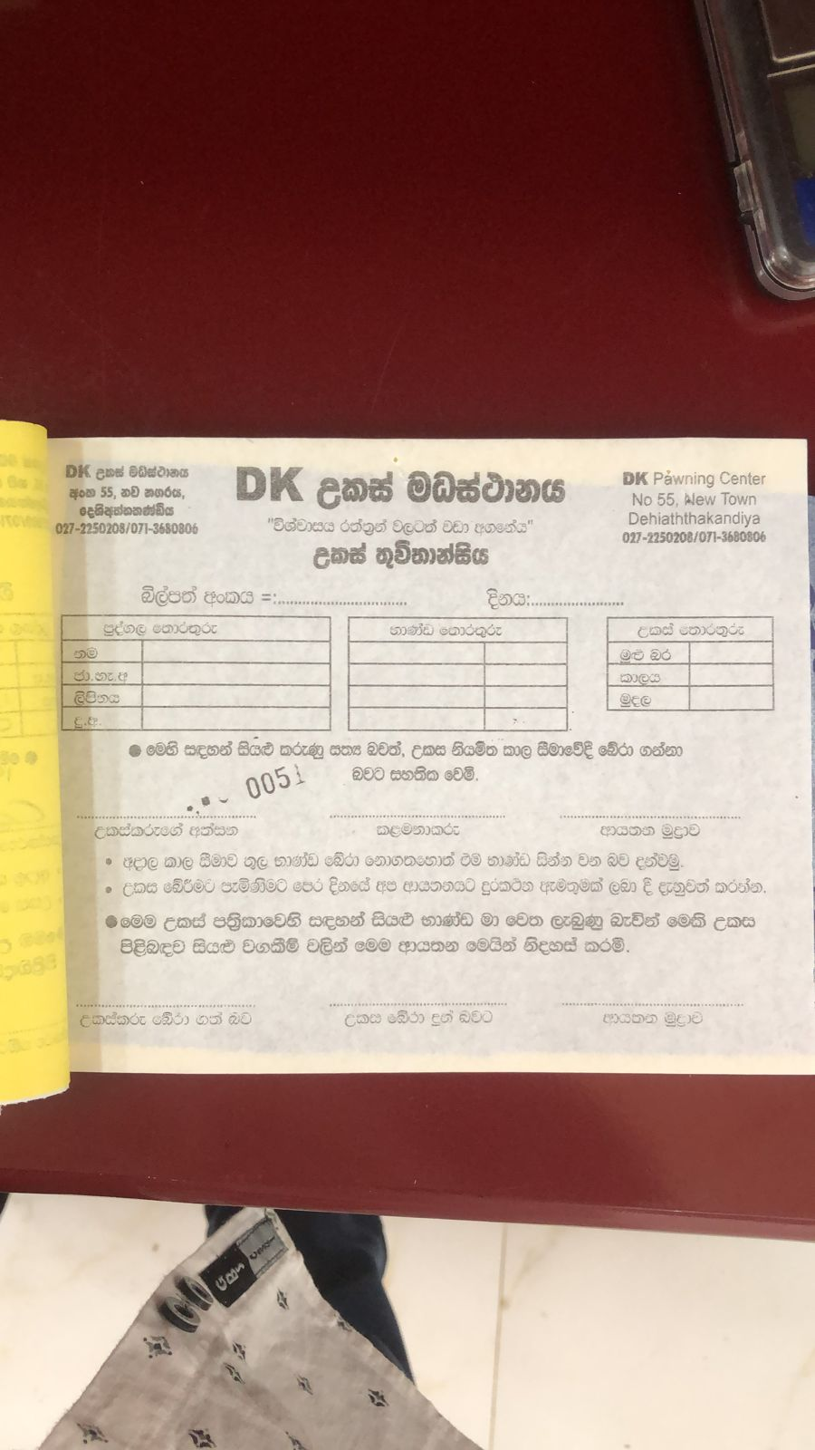After the owner calculate the mortgage price and the interest rate based on the prevailing gold price, the customer decides whether to pawn the gold items or not. After the customer made his/her decision to pawn the gold item/s the mortgagee opens a form paper to include customer personal details. For that the mortgagee takes customers’ full name, address, mobile number, NIC number. Then take the details of, gold item/s type, weight of each item & total weight of gold, money that can give, interest rate & given time from the owner and include them in the form. Then start to fill the bill with the collected details and get the signatures of the customer & the owner in the bill. At the end of the main process the customer receives respective amount of money, and the original copy of the bill and owner will store the gold items at the store safe.

***Img.3***

The completed report and the carbon copy of the bill sends to the bookkeeper, and he store them in respective files. The bookkeeper does all the accounting things and maintain the files. The shop owner responsible to deal with the banks and make transactions with the customers and the banks.

Problems of the process…

For this project we choose the main process of the company which the process starts when the customer brings their gold items to the shop, and it ends after the customer receive the money with the mortgage card. In this case, D.K. Pawning Center currently using a physical file-based system to do the above-mentioned process and other processes of the businesses with three human work force. All the business records, customer details are saved in files and issue bills by writing details on the printed bill books. They use normal paper mail system to send details to their customer and if there is an urgent message to send, use mobile phone calls. When considering the key performance indicators to measure the business process it mainly effect the time and cost of the business.

**Time: -**